Arcola Home & School Association
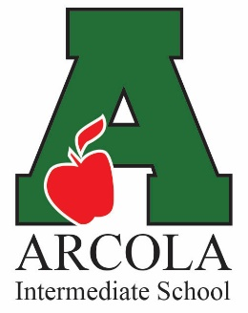

2019/2020 “No-Frills” Fundraiser

Nothing to Buy! One and Done! Nothing to Sell!

Hello Arcola Families!

It’s the start of a new year – new programs with a new budget – so we need your help in raising funds for the planned enrichment activities sponsored by Arcola H&S Association.

Instead of engaging in fundraising that only shares a percentage of the proceeds,
we’ve opted for a direct-donation process as our primary fundraising tool …

100% of your no-frills contribution will go towards the kids and their programs.

It’s as simple as that!
Please contribute and be a part of our success!

Funds raised will be used to help us accomplish our goals:

Facilitate open communication between administration, teachers and families
Organize awesome activities and events for our entire student body
Fund mini grants to enhance our student’s educational experience
Promote positive community interactions and involvement
Support and encourage school spirit and pride

In order to support these goals, we need the assistance of EVERY Arcola family. The average suggested donation per family is a one-time $25 to $50, but any amount is greatly appreciated.

Our goal this year is to raise $10,000 to provide an entire year of
enhanced activities for over 800 students and faculty.

Please fill out and return the bottom section of this flyer along with your donation
in an envelope marked “H&S No Frills”. Donations can be turned in to your students first period teacher or to the school office.

Checks should be made payable to Arcola Home and School Association (AHSA).
Arcola Home & School Association is a 501(c)3 non-profit organization under the umbrella of The Methacton Coordinating Council. Your donation is tax deductible as allowed by law. No goods or services were provided in exchange for your donation. This letter/form serves as your receipt for your donation along with your cancelled check.

2019/2020 ARCOLA HOME & SCHOOL - NO-FRILLS FUNDRAISER

Student Name: _______________________ Grade & Team: _______________________

Donation Amount: ______________________________

